SEBIN JOSEPH
sebin_joseph1992@yahoo.com +91 9930184553

Enthusiastic young professional with 2 years of Experience in FMCG Sales & Distribution line. Currently working as a Territory Sales Executive in Abbott Healthcare Pvt Ltd (Nutrition). Looking after entire Chhattisgarh territory & based at Raipur HQ.

AREAS OF EXPERTISE

- FMCG Sales
- Distribution Management

- Distributor Management ( Pharma & Trade )

C
- Driving Primary & Secondary Sales

- Area & Business Planning

- Field Force Management & Development

PROFESSIONAL EXPERIENCE

Territory Sales Executive: Abbott Healthcare Pvt Ltd, May 2015 to Present

Responsibilities:

- Ensure Achievement of monthly, quarterly & annual agreed sales targets within laid out business terms for all brands.
- Monitoring Distributors & Field force at a beat level.
- Identify potential towns & Appoint distributors in line with business strategy
- Formulate & Execute Secondary sales plan- Area wise, Distributor wise, Brand wise, SKU wise weekly and monthly.
- Ensuring quality of market coverage through effective use of ISR’s & distribution network.
- Ensure implementation of Trade & Consumer promotion plans & Support Micro-marketing & Customer Activation initiatives planned for the area.
- Hiring, Training & motivating Field force to get the desired results.
- Data management & Reporting.

Accomplishments:

- Significantly brought growth in Primary & Secondary Sales In Chhattisgarh
- Effectively handling a total of 18 distributors all over Chhattisgarh. ( 9 Pharma, 9 Trade & 1 Super Stockist )
- Developed the markets significantly & improved the retail coverage of Pediasure as a Brand.

INTERNSHIP

Management Trainee: VIP Industries Limited, 2months (Mumbai & Chennai)

Project Title- ‘Mapping VIP Luggage in the Emerging Markets of Chennai’

KRA:
- Study of Dealers/Distributors & Retailers
- Positioning of VIP Luggage
- Counter-share Study
- Market Research in the respective sphere with the help of Business Development Executives & Long Sales Arm Force

Responsibilities:

- Identifying of Suburbs in Chennai & Carrying out Market Visits.
- In-depth interviews of luggage retailers and overall market study of competitors & peer brands.
- Collection of data using Questionnaires & Photos.
- Analyze data, make conclusions and recommendations, submit a report & give a final presentation.

EDUCATION:

- MBA / Masters of Management Studies (MMS) in Marketing : Bharati Vidyapeeth Institute Of Management Studies & Research, Mumbai (2015)

- Bachelor of Commerce (B.Com): Bhavans College, Andheri, Mumbai (2012)

- HSC – Bhavans College, Andheri (2009)
- SSC – Holy Family High School, Andheri (2007)

COMPUTER KNOWLEDGE:
- MS Office Word
- MS Excel
- MS PowerPoint
- Adobe Photoshop

Certifications: Certificate Course on Computer Technology (CCCT)
German Language Course (A1)

EXTRA CURRICULAR ACTIVITIES

- Vice- President and also the WEBCOM Director of the Rotaract club of BVIMSR. (Disrict.3140)
- Was part of the managing team in the 25th AIMS Annual Convention held at BVIMSR
- Student Editor of B.V.I.M.S.R (Chief Designer of the College Newsletter ‘INGENIUM’)
- Was in the Organizing committee of an Inter-college fest ‘SHIKHAR’14’ (Creative Head)
- 1st Prize Winner of a Photography competition in the Inter-college fest SHIKHAR’14
- Was a part of the Annual Alumni Meet’14 organizing committee (also designed Invitation cards for over 1500 Alumni and various posters for the event)
- Participated in a Social Film Making Competition conducted by ‘Yes Foundation’
- Organized and designed a Seminar named ‘Brand Mania’ in BVIMSR for strength of 150 students.
- Participated in an Inter-collegiate Business Quiz Competition held at YMT College, Kharghar Core member of Shikhar’14 (College Fest)
- Played Football for my School and Degree College.

COMMUNITY SERVICE:

- Past active member of Rotaract Club of Navi Mumbai.

- Have served as the Vice President of Rotaract Club running under Parent Rotary Club
(RC BVIMSR District 3140)

PERSONAL DETAILS:

Date of Birth: 12th May 1992
Languages Known: English, Hindi, Marathi, Malayalam, German (Beginner)
Hobbies: Photography, Photo Editing (Photoshop), Listening to Music, Football & Chess

STRENGTHS & ATTRIBUTES

- Strong communication and Interpersonal skills.
- Pleasing personality, optimistic attitude.
- Keen & Enthusiastic and Quick Learner
- Organized, dedicated, sincere and systematic
- Team Player
- Strong ability to achieve immediate and long-term goals and meet project deadlines.
- Honest, Hardworking & Proactive.
- Leadership Skills
- A creative eye for any challenge.

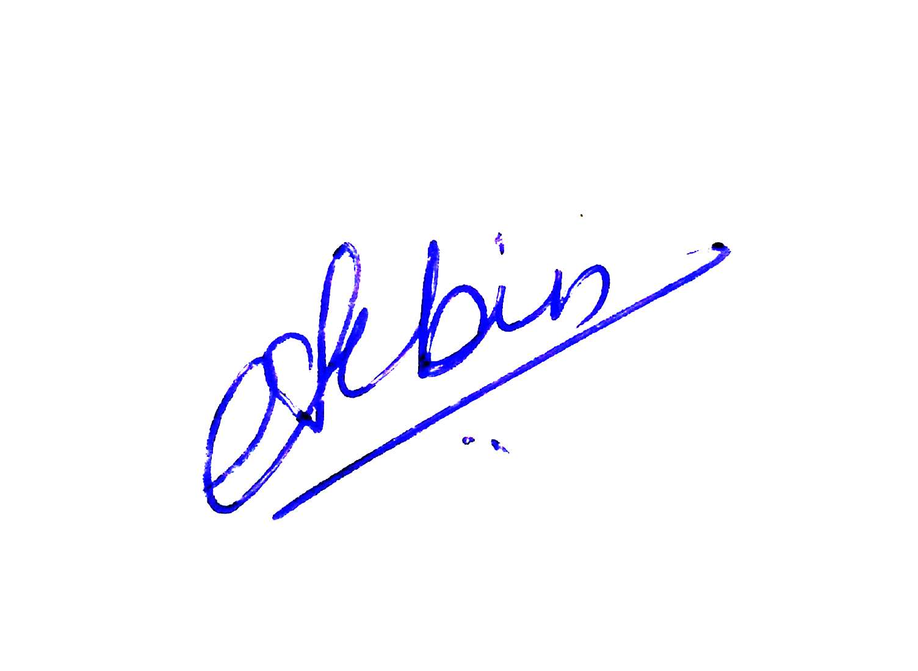
I hereby declare, all the above information provided is correct & to the best of my knowledge.

Date:
Place: Mumbai Signature.

XXXXXXXX

